Label iQ Demo Walkthrough

Massive Insights
Drug Label AI Assistant - Powered by Denodo AI SDK
Patient, Physician, and Judge Walkthrough
Basic drug information access with patient-friendly filtering
1
Login as Patient
Select "Patient" from the role dropdown and enter credentials:
Username | patient
Password | patient
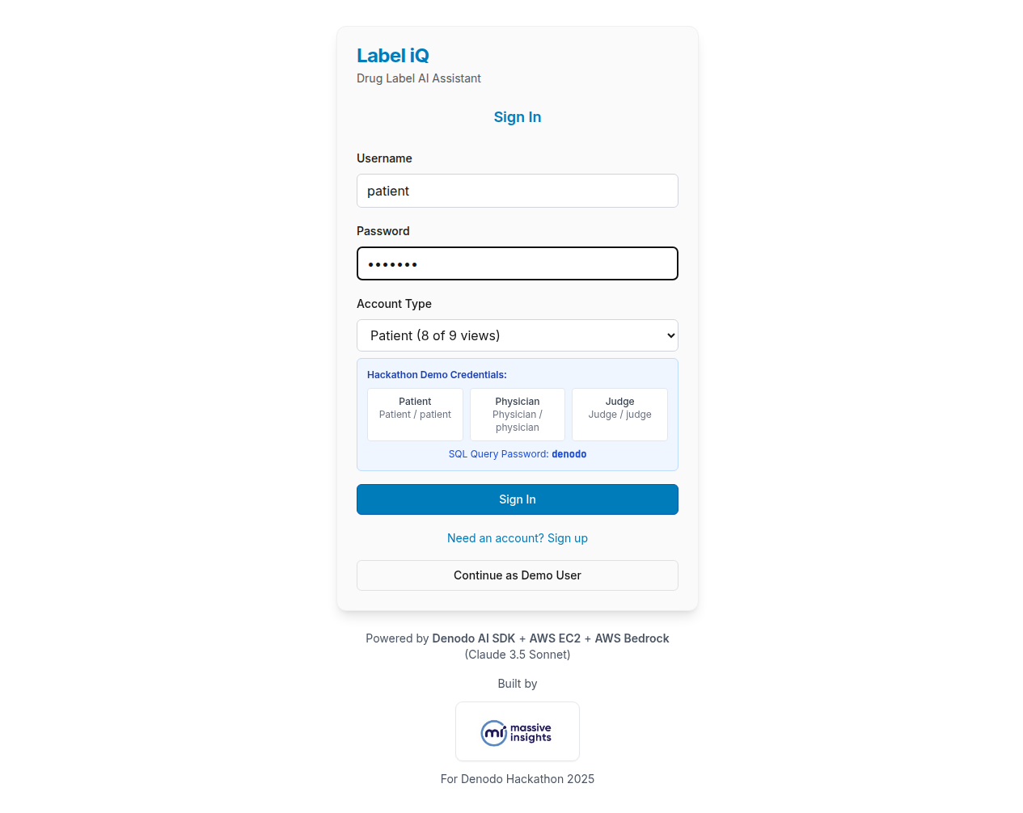
2
Drug Selection Grid
After login, you see the drug grid with a "Patient View" badge indicating your access level.
Patient role has access to 8 of 9 database views. Technical risk assessments are filtered with a disclaimer.
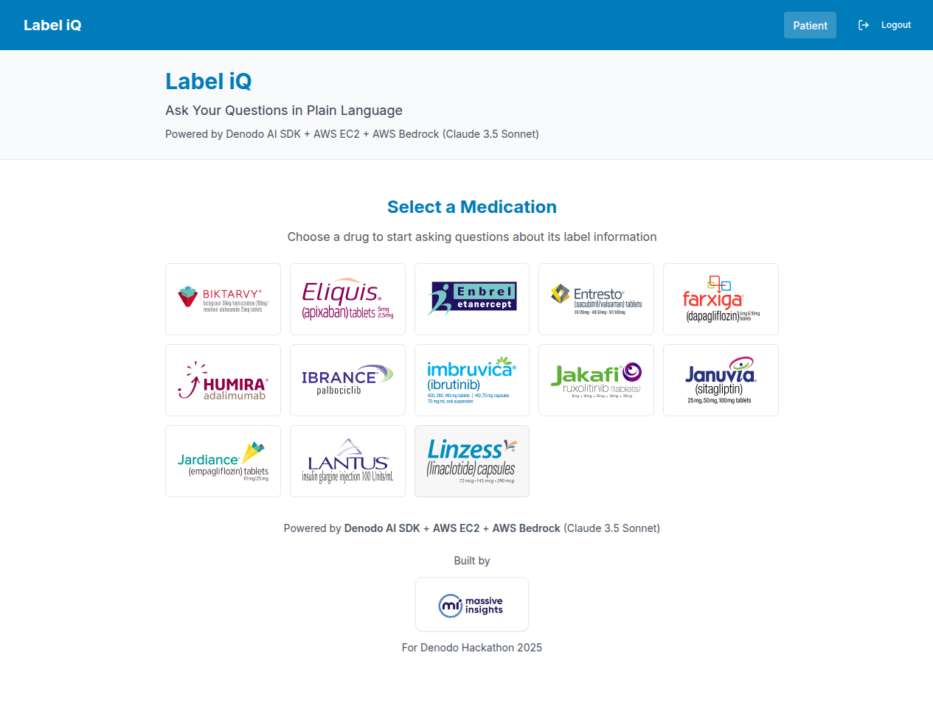
3
AI Response
The AI provides clear, patient-friendly drug information. If restricted data was accessed, a disclaimer is shown advising to consult a healthcare provider.
- Clear, readable drug information
- Data Sources shown below response
- Disclaimer if technical data included
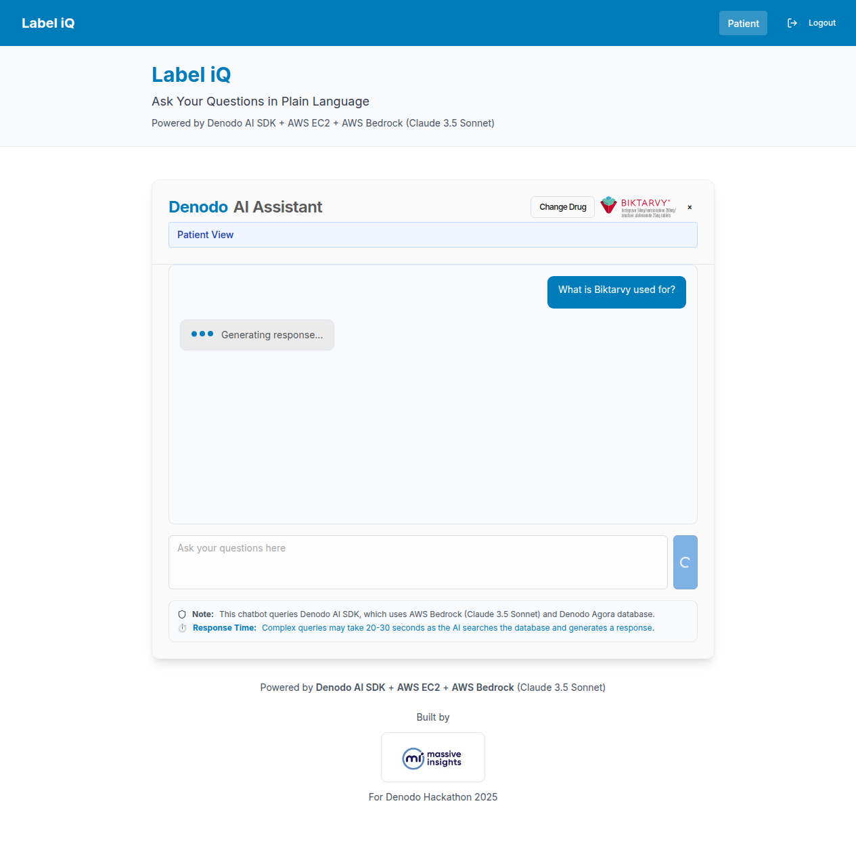

Physician Walkthrough
Full access to all drug data and clinical information
1
Login as Physician
Select "Physician" from the role dropdown and enter credentials:
Username | physician
Password | physician
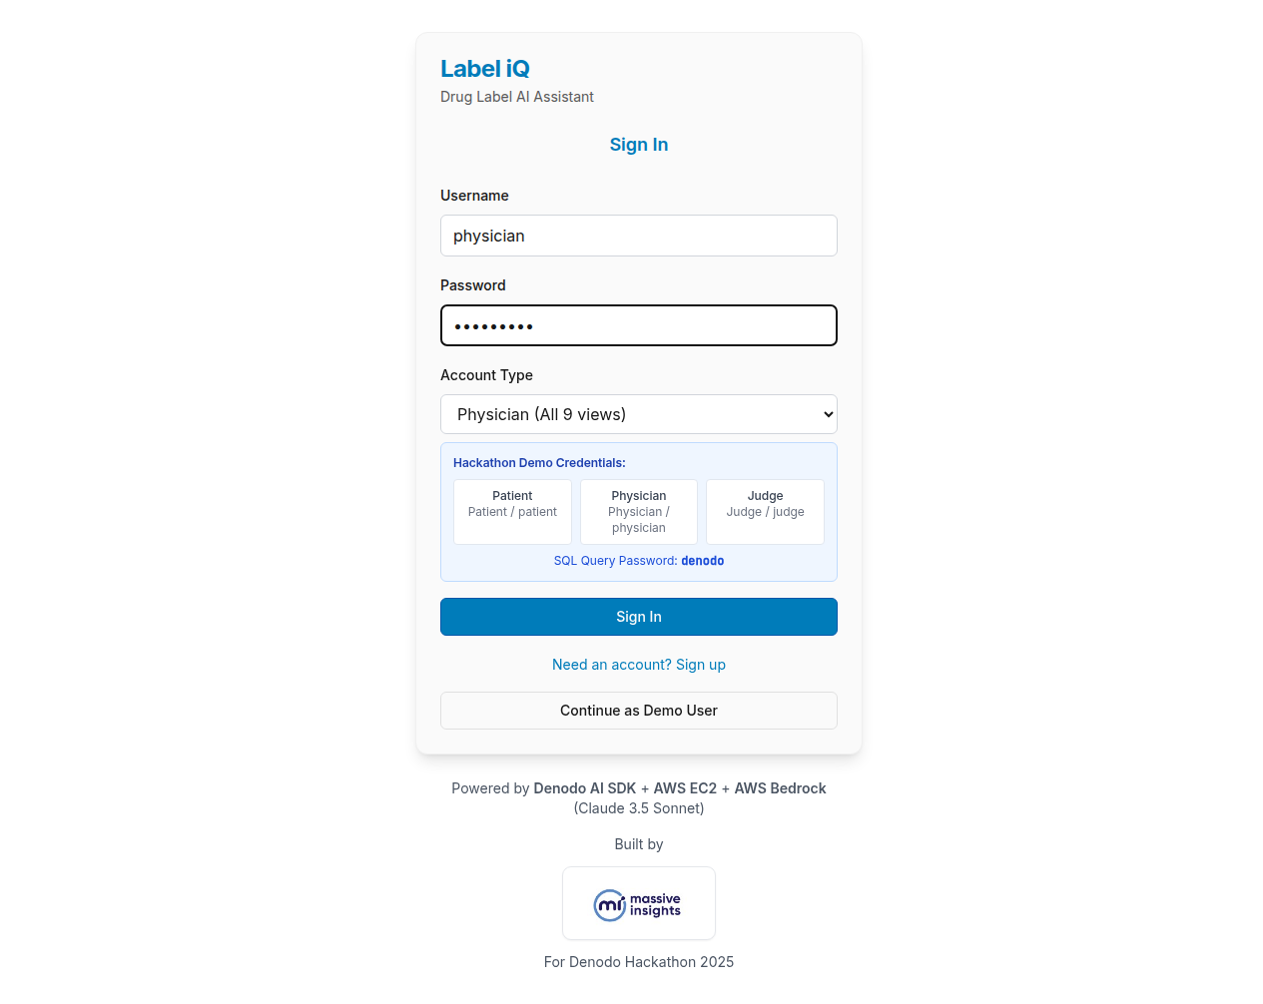
2
Drug Selection Grid
The Physician view shows the drug grid without any access restrictions badge.
Physicians have full access to all 9 database views including clinical details and safety assessments.
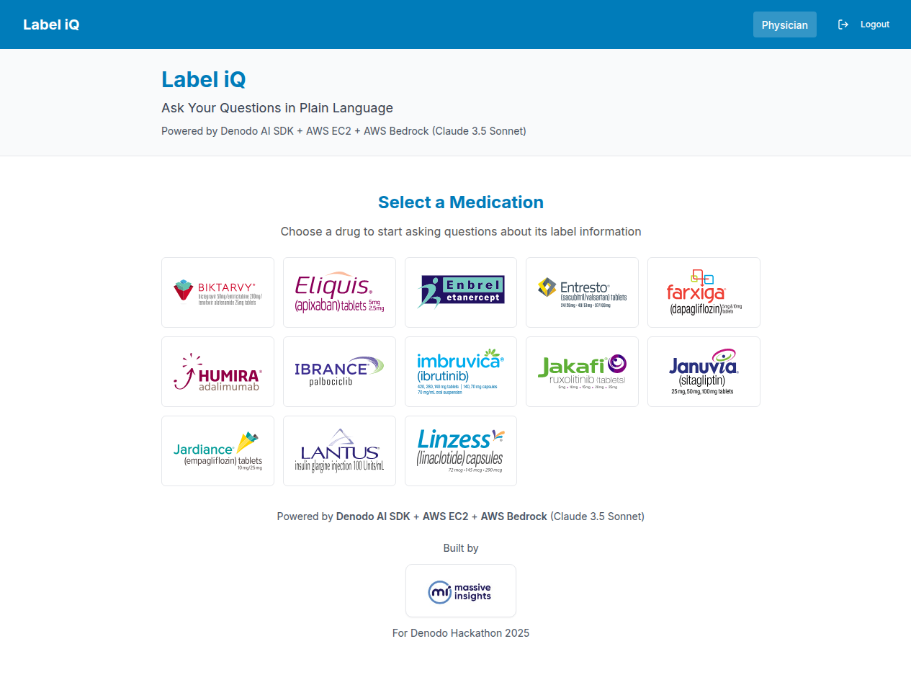
3
Complete AI Response
Physicians receive complete drug information with all data sources displayed. No content is filtered or restricted.
- Full clinical drug information
- All Data Sources visible
- Complete safety and dosing details
- No disclaimers or restrictions
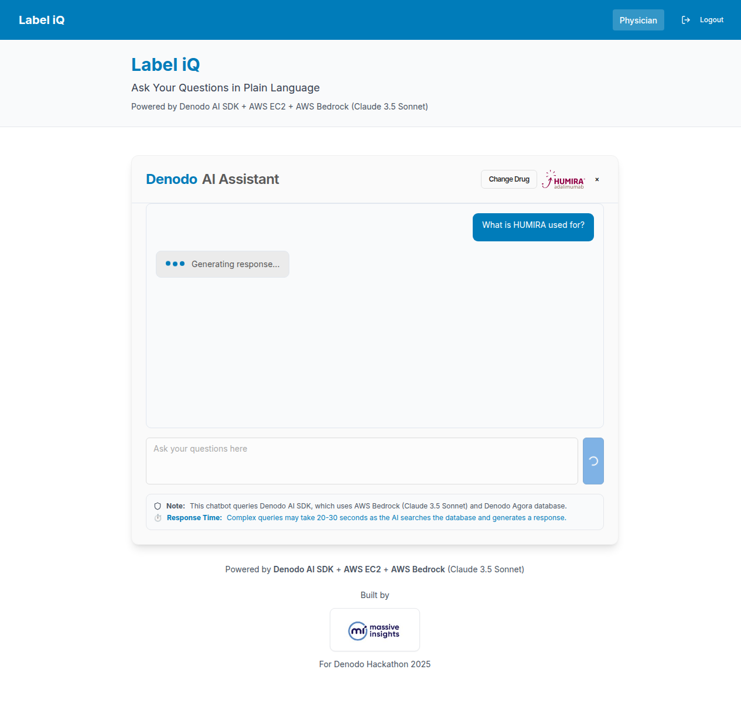

Judge Walkthrough
Full access plus SQL query visibility for technical evaluation
1
Login as Judge
Select "Judge" from the role dropdown and enter credentials:
Username | judge
Password | judge
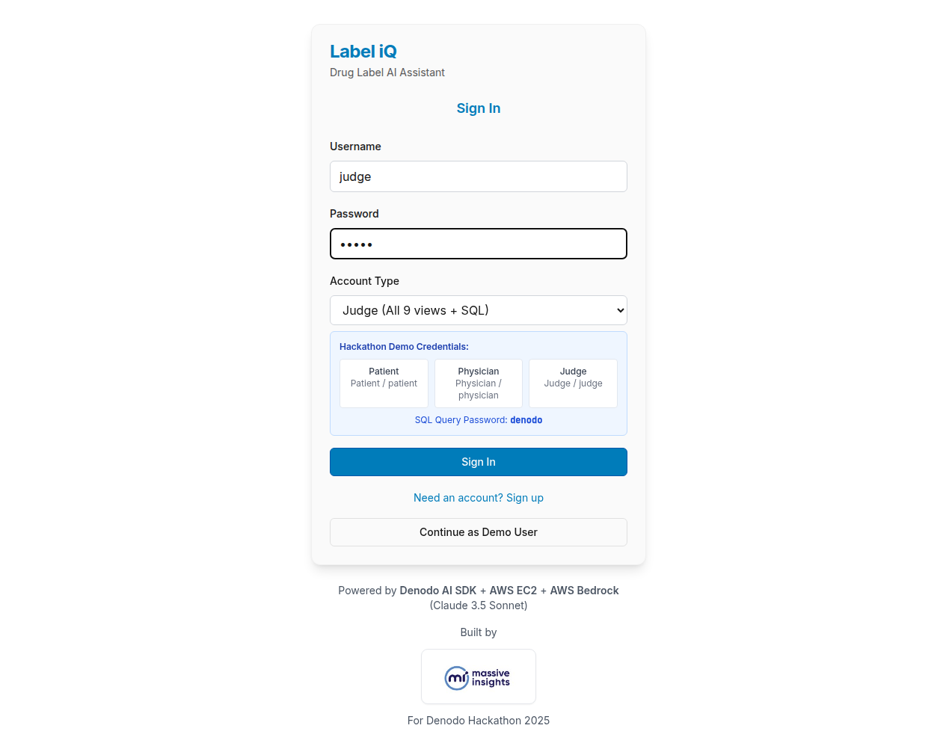
2
Drug Selection Grid
The Judge view shows the same drug grid as Physician with full access to all data.
Judges have the same data access as Physicians, plus the ability to view generated SQL queries.
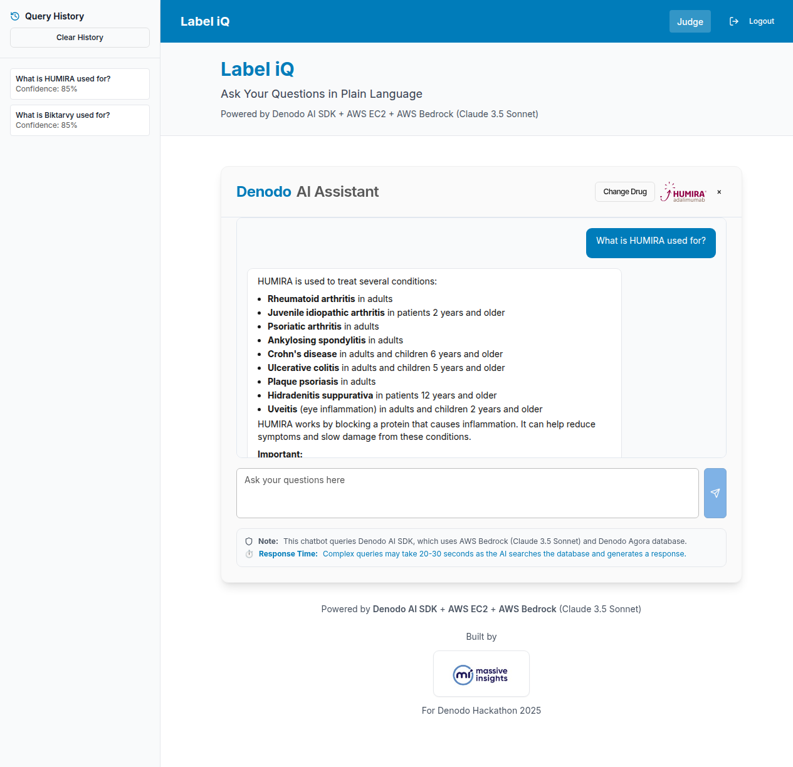
3
AI Response with SQL Query
Judges see a "View SQL Query" button below the response. Click to expand and enter password to view the actual SQL generated by the AI.
- Full drug information like Physician
- SQL Query section (expandable)
- Password-protected SQL view
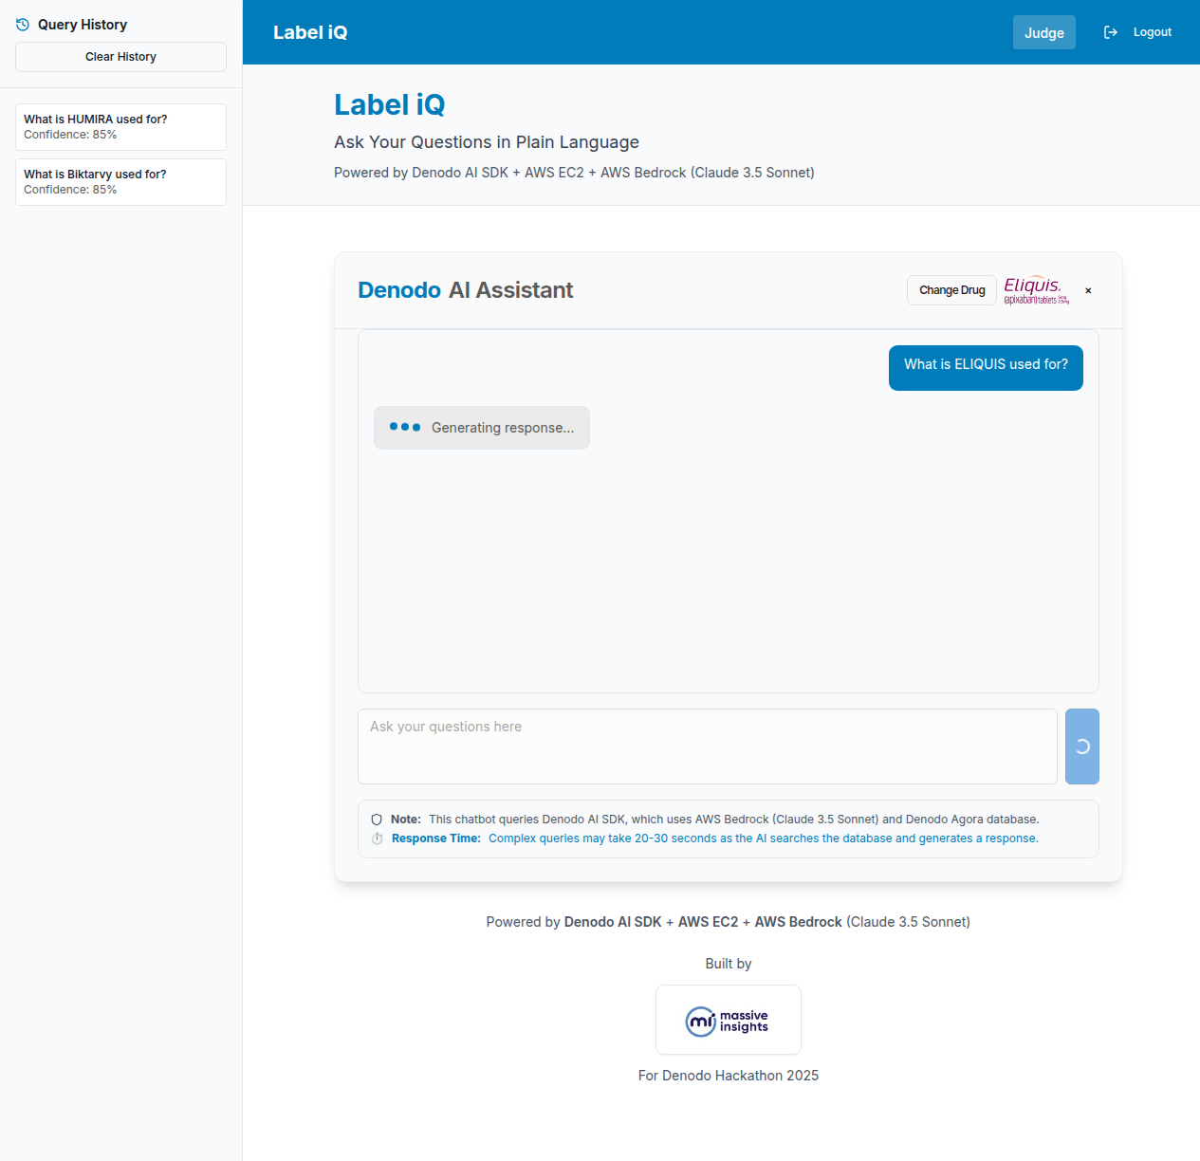
4
View SQL Query
Click "View SQL Query" and enter the password denodo to see the actual SQL generated by the Denodo AI SDK.
This feature allows judges to evaluate the AI's query generation and understand how natural language is translated to SQL.
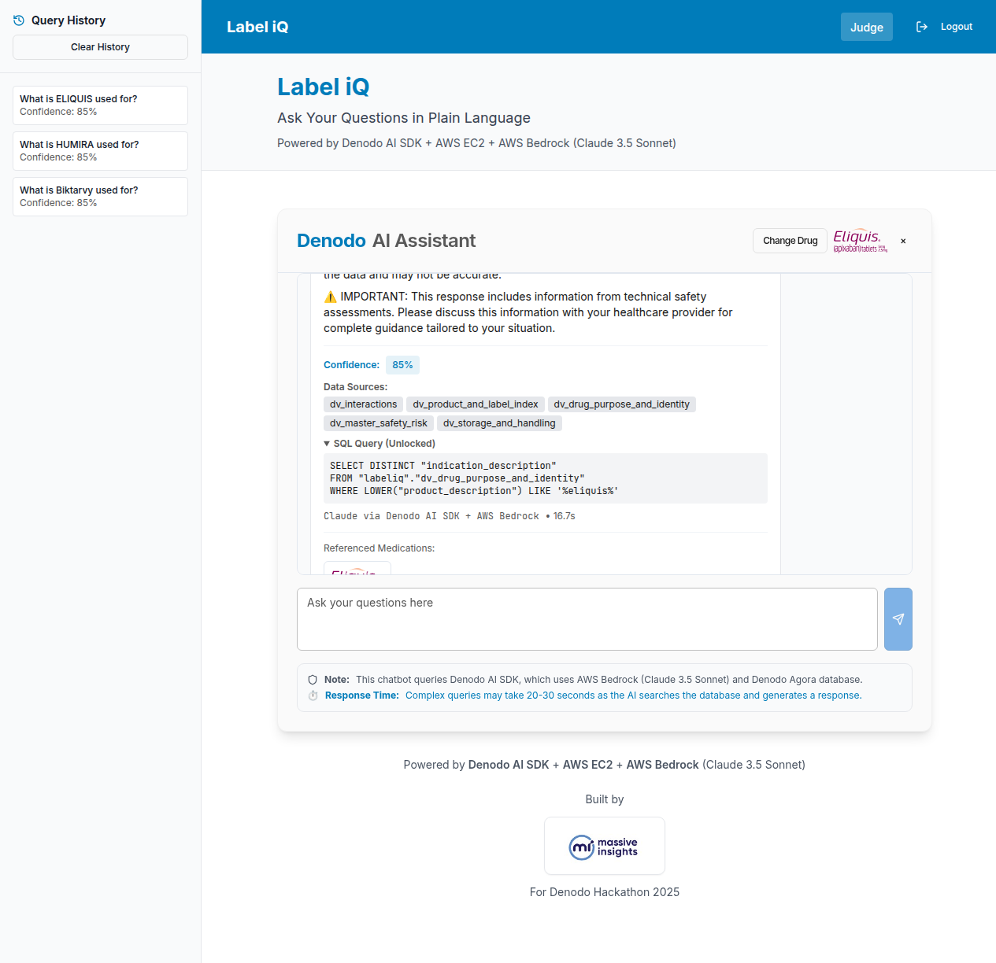
i
Role Comparison Summary
Feature | Patient | Physician | Judge
Drug Information | Yes | Yes | Yes
Data Sources | Yes | Yes | Yes
Full View Access | 8 of 9 | 9 of 9 | 9 of 9
SQL Query View | No | No | Yes
Technical Disclaimers | Yes | No | No

Label iQ - Denodo Hackathon 2025

